**Introduction to ER Model**

Table of Contents

Entity, Entity Type, Entity Set 2

Attribute(s) 2

Key Attribute 3

Composite Attribute 3

Multivalued Attribute 3

Derived Attribute 4

Weak Entity Set 5

Strong Entity Set 5

Relationship Type and Relationship Set 5

**ER Model** is used to model the logical view of the system from data perspective which consists of these components:

# Entity, Entity Type, Entity Set

An Entity may be an object with a physical existence – a particular person, car, house, or employee – or it may be an object with a conceptual existence – a company, a job, or a university course.

An Entity is an object of Entity Type and set of all entities is called as entity set. e.g.; E1 is an entity having Entity Type Student and set of all students is called Entity Set. In ER diagram, Entity Type is represented as:

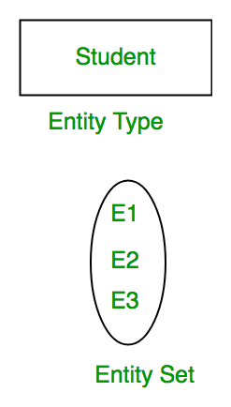

Attribute(s)  
Attributes are the **properties which define the entity type**. For example, Roll_No, Name, DOB, Age, Address, Mobile_No are the attributes which defines entity type Student. In ER diagram, attribute is represented by an oval.

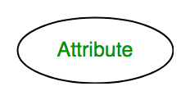

## Key Attribute

The attribute which **uniquely identifies each entity** in the entity set is called key attribute. For example, Roll_No will be unique for each student. In ER diagram, key attribute is represented by an **oval with underlying lines.**

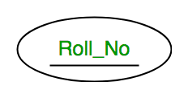

## Composite Attribute

An attribute **composed of many other attribute** is called as composite attribute. For example, Address attribute of student Entity type consists of Street, City, State, and Country. In ER diagram, composite attribute is represented by an oval comprising of ovals.

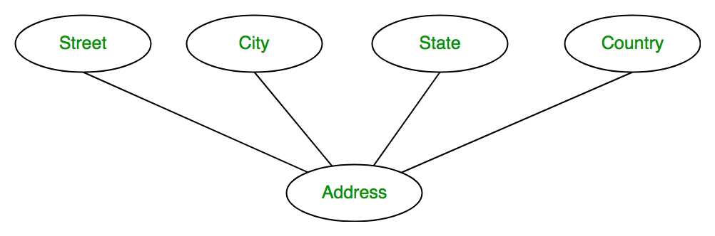

## Multivalued Attribute

An attribute consisting **more than one value** for a given entity is multivalued attribute. For example, Phone_No (can be more than one for a given student). In ER diagram, multivalued attribute is represented by double oval.

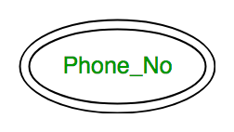

## Derived Attribute

An attribute which can be **derived from other attributes** of the entity type is known as derived attribute. e.g.; Age (can be derived from DOB). In ER diagram, derived attribute is represented by dashed oval.

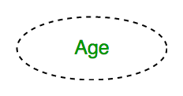

The complete entity type**Student** with its attributes can be represented as:

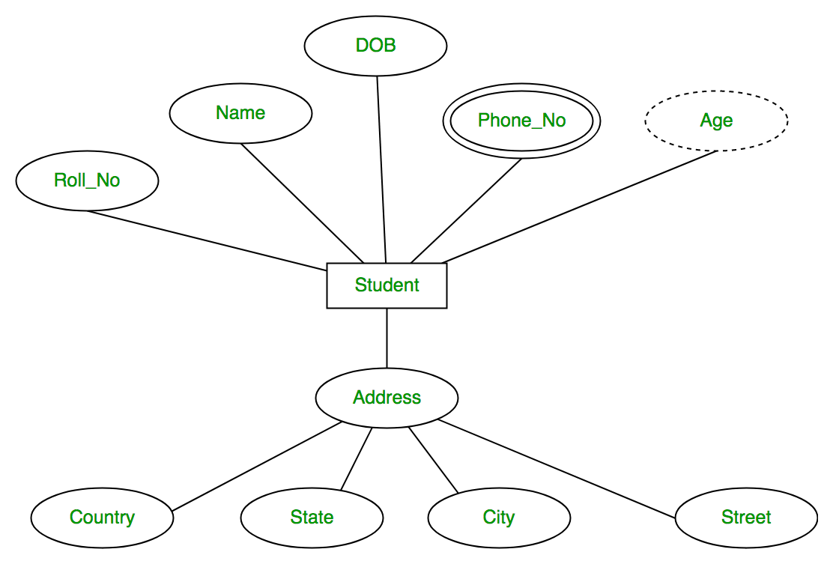

# Weak Entity Set

An entity type should have a key attribute which uniquely identifies each entity in the entity set, but there exists some entity type for which key attribute can’t be defined. These are called Weak Entity type.

The entity sets which do not have sufficient attributes to form a primary key are known as **weak entity sets** and the entity sets which have a primary key are known as strong entity sets.

**Weak entities** are represented with **double rectangular** box in the ER Diagram and the identifying relationships are represented **with double diamond**. Partial Key attributes are represented with dotted lines.

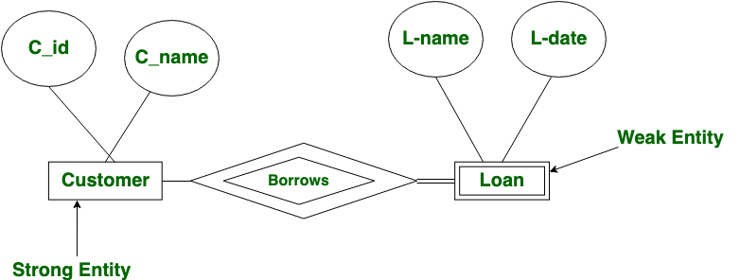

# Strong Entity Set

# Relationship Type and Relationship Set

A relationship type represents the **association between entity types**. For example, ‘Enrolled in’ is a relationship type that exists between entity type Student and Course. In ER diagram, relationship type is represented by a **diamond** and connecting the entities with lines.

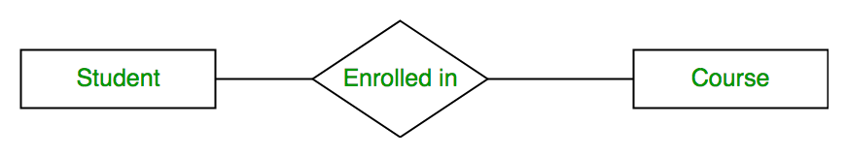

A set of relationships of same type is known as **relationship set**. The following relationship set depicts S1 is enrolled in C2, S2 is enrolled in C1 and S3 is enrolled in C3.

